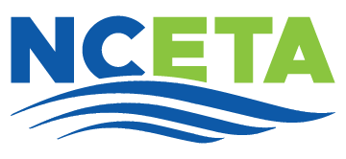
NCETA 2026 CONFERENCE REGISTRATION FORM

www.nceta.org
Game Changers: Bold Moves for a New Era
May 6-8, 2026 Wilmington, NC
Directions for completing form:
- If you organization is paying for multiple attendees and/or paying by check, please complete this form and return it to info@nceta.org to confirm registration.
- Mail a copy of this form and payment to:
Remit to: North Carolina Employment & Training Association
c/o Malinda Marsh, President
P. O. Box 16
Siler City, NC 27344

Name | Title | E-mail Address | Phone Number | Organization | Current NCETA Member? (Y/N) | First time attendee? (Y/N) | Total paid for Attendee (see rates below)
Add attachment if additional space is needed.
IMPORTANT NOTIFICATIONS:
Reminder: Early Bird Registration ends April 15, 2026.
Hotel reservations must be made separately using the conference booking link.
Early Bird Member Rate (by 4/15/26) | Early Bird Non-member Rate (by 4/15/26) | Late Registration Rate | New Member Registration
$350.00 | $375.00 | $400.00 | $25.00

NCETA 2026 CONFERENCE REGISTRATION FORM

www.nceta.org
Game Changers: Bold Moves for a New Era
May 6-8, 2026 Wilmington, NC

Payment Information:
Total Number of Attendees:
Total Amount Enclosed ($):
Check Number:
Form Submitted by:
Name: Title: Organization:
E-mail Address: Phone:

We look forward to seeing you in May! We appreciate your support of the North Carolina Employment and Training Association.

